Altbier

Background:
Ale has been brewed in the area around Germany for thousands of years, probably since around 1000 b.c. (Dornbusch, 6), where the tribes would brew the grains which grew wild there.
This style of beer emerged in the northern part of Germany, around Dusseldorf. After lager beer had become popular from the south (Bavaria), it virtually took over as the beer produced for consumption. People in the northern parts of Germany demanded their beer be produced using the old style, hence the name emerged post-period for the SCA in the 1800s. The style of brewing there, though, remained unchanged from well back into the SCA period.

Description of Altbier (Oliver, pp 36-37)
Crisp, clean-tasting, full bodied; 4.7-4.9% ABV; copper color; firm white head; malty to nutty finish.

The yeast selection is important to this style, as well as a protein rest at lower temperature (125F) during mash.

Process selection:
Using the Dornbusch book, “Altbier” I perused the various recipes. I also looked online and found many recipes for Altbier, settling finally on the one named Altstadt Alt from Dornbusch.
This beer was started three weeks before serving time, so it is very young for an “old” beer. Normally, this would have sat in a secondary carboy for some time, and then aged further in a keg before serving.

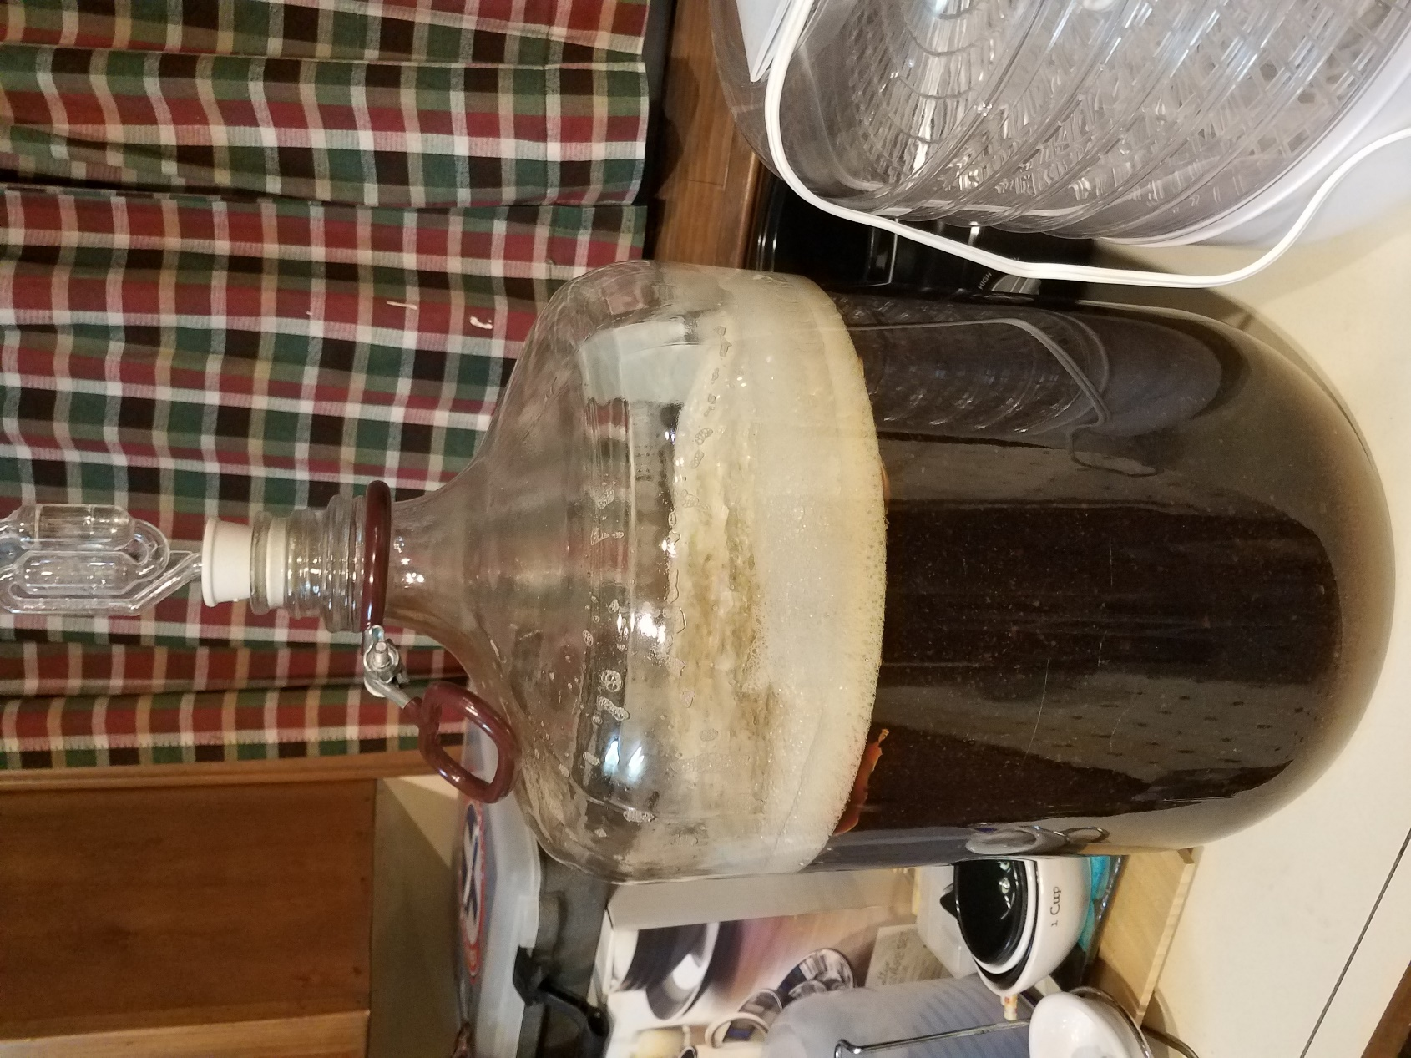

Typical beer of this style during primary ferment (not this actual batch)

Recipe (Altstadt Alt):
6 lb Two-row malt
1.5 lb. Munich malt
1.5 lb. Vienna malt
1.0 lb. Crystal 60 degree
Hallertau, Hallertau, Spalt (Bittering, Flavoring, Aroma)
Wyeast 1007

After the mashing and boil, a hydrometer reading was taken and written down, but in my haste I misplaced the information so I do not have the exact numbers. Typical for this style, though, would be a starting gravity of 1.048 and finishing at approximately 1.010, producing a 5% ABV beer.

References:
Dornbusch, Horst D; Altbier: History, Brewing Techniques, Recipes; Brewers Publications, 1998
Oliver, Garrett; The Oxford Companion to Beer; Oxford University Press, 2012

