Acetum Vinum
(Wine Vinegar)

Background:
Vinegar has been around a really long time, like REALLY. Many stories recorded through history contain references to vinegar, from Hannibal’s crossing the Alps in 218 BC to Biblical references, to the writings about the plagues of Europe. Some of these stories are likely apocryphal, but it is clear from the abundance of anecdotal references and direct mentions that vinegar has been present in large quantities almost as long as fermented alcohol has been. More than the stories, recipes throughout the ages include the use of vinegar as flavoring and preservative.
The name vinegar specifically comes from Old Latin for sour wine – vin acer. The name changed over time and in various languages, like the French phrase vin aigre and the later Latin version, acetum vinum. There are other terms sometimes used, such as alegar when beer is the source instead of wine.
Hannibal is said to have used vinegar to melt rocks in a pass during his famous crossing of the Alps. It is doubtful his army carried sufficient quantities of vinegar to do this, but it is possible that the vinegar had some softening effect on the calcium-containing rocks, or that when they boiled it and poured it on the rocks, it would have cracked the frozen rocks into smaller pieces that could then be moved.
As another example, the Roman army used vinegar in a drink known as posca, served at meals. From the middle east, we know of Sekanjabin, a Persian drink consisting of vinegar, water, honey, and sometimes herbs such as mint.
There are not many historic sources with instructions or recipes for making vinegar, but its ubiquitous presence cannot be overlooked. In any case, it has been known since before common era that fermented liquids such as ale or beer, wine, cider, and even mead turns to vinegar, and that vinegars are useful in cooking, flavoring, and preserving food as well as other uses.
It makes sense that vinegar production worked hand-in-glove with alcohol production. Vinegar is created through a natural process known as acetification, wherein fermented alcohol is exposed to acetobacter molecules and oxygen. The process occurs spontaneously when certain fermented liquids are exposed to air over time.
Process selection
For this project I chose to use red wine. I had recently begun making wine, and about a year ago I decided to use some to make red wine vinegar. Since then, I have made a second batch of the same red wine and recently started a second batch of vinegar using mother from the first batch. The vinegar presented today is from the original batch that is fully converted, and the wine is from the new batch to compare the flavor of what this source material tastes like before and after acetification.
I have used a kit to make red wine because I personally love dry red wines. While I have been brewing beers and meads for many years, I had never made wine before, so I wanted a simple way to make wine to better understand the process. It turned out very well, and I used some of it (about a gallon) to make red wine vinegar, using the vinegar generator I will mention later in this document.
The Cycle
Starches are produced by plants, which are then changed to sugars under certain conditions (mashing, for instance). The sugars are eaten by yeast and produce alcohol. Finally, acetobacter molecules combine the alcohol with oxygen to form acetic acid. Any fruit or vegetable matter with enough sugar or convertible starches can be used.
Left to its own devices, wine below a certain threshold (about twelve percent alcohol) will always go sour if exposed to air. If the wine is below four or five percent, after acetification occurs you will still have vinegar – but it will be susceptible to other infections and not be acceptable as a preservative or antiseptic.
In a container of fermented liquid there is a transition layer at the surface where the change is occurring. The built-up layers of acetobacter form a blanket floating on the surface known as a “mother”. Over time, the mother thickens, and eventually sinks (see figure 6). When that happens, the mother will dissolve in the resulting vinegar.
Methods
Markham’s methods:
To Make Vinegar
To make excellent strong vinegar, you shall brew the strongest ale that may be, and having tunned it in a very strong vessel, you shall set it either in your garden or some other safe place abroad, where it may have the whole summer’s day sun to shine upon it, and there let it lie until it be extreme sour, then into a hogshead of this vinegar put the leaves of four or five hundred damask roses, and after they have lain for the space of a month therein, house the vinegar, and draw it as you need it. (Markham, 133)
To make the best vinegar
Take and brew very strong ale, then take half a dozen gallons of the first running, and set it abroad to cool, and, when it is cold, put yeast unto it and head it very strongly: then put it up in a firkin; and distil it in the sun; then take four or five handful of beans, and parch them in a pan till they burst; then put them in as hot as you can into the firkin, and stop it with a little clay around the bung-hole: then take a handful of clean rye leaven and put in the firkin; then take a quantity of barberries, and bruise and strain them into the firkin, and a good handful of salt, and let them lie and work in the sun from May until August: then, having the full strength, take rose leaves and clip the white ends off, and let them dry in the sun, and, when they are dry, put them in bags, and keep them all the winter: then take a little pot, and draw forth a pottle out of the firkin into the bottle, and put a handful of the red rose leaves, and another of the elder flowers, and put into the bottle, and hang it in the sun, where you may occupy the same, and, when it is empty, take out all the leaves, and fil it again as you did before. (Markham, 135)
Declan’s generalized method
First, you’ll need to choose a source material, such as barley malt for malt vinegar; or honey, grapes… any of these will make alcohol for you when combined with the right ratio of water and yeast. If using fruit and doing your own fermentation, be sure to add pectic enzyme and also yeast nutrient. Also ensure you have enough sugar in the solution. Use a hydrometer to measure the specific gravity to give a potential alcohol reading. It should be a percent or two above what you want your vinegar to be.
For instance, if you want your vinegar to be 7% acetic acid, you will need about 7.5% alcohol. So put enough sugar in solution to read 7.5% potential alcohol. Consult other sources as necessary for specifics.
When preparing the sugar solution, sanitation is critical. You may boil or not, but you will need to fanatically clean everything that will touch the solution (see figure 2).
Mix the sugar solution up, add your yeast, and use a fermentation lock. Wait for a week or more (it should bubble in a day or so and get very yucky-looking). After a week, you’ll want to get the main part of your alcohol solution off of the trub (the sediment). After some longer time when no more bubbles are seen at the fermentation lock, it’s time to transfer the liquid into another vessel for the vinegar conversion.
After your vinegar mother has grown, you can use a funnel, with a small hose attached to the bottom, to transfer new liquid in without disturbing the mother too much. This will allow your vinegar production to be a continuous cycle.
Cover the top of whatever you are using (I use cheesecloth and a rubber band).
Then, you will need patience, or another diversionary hobby to wait a few weeks for the conversion to take place.
After conversion is complete, you are ready to use the vinegar directly, or age it. While aging, you can infuse it with herbs. Ten days to two weeks of the infused herbs and you are well on the way to a delicious herbed vinegar of your own.

The Orleans method (for the location it was developed in France):
In the Orleans method, a barrel is typically placed on its side with vent holes (or even cheesecloth) covering a portion near the top of the side, allowing for good movement of air, and blockage of bugs. The bung opening is at the top so fresh liquid can be poured in (near the bottom using a tube) and also siphoned out (from near the top when conversion is complete).
A Vinegar Generator
The process is so simple it seems that medieval authors rarely wrote instructions for how to make it, perhaps regarding it as too simple to need an explanation. One makes something with sugar, and leaves it in the open to ferment, making alcohol; thence to proceed to vinegar, through a process we now know as acetification. Refining that definition, one needs to have a container for an alcoholic liquid, which has a large opening to allow oxygen in, and a screen covering to keep out bugs while the process proceeds.
Reading about this in the methods recommended, I noticed the idea of setting a large amount of ale or wine out in a garden area for a time until it sours – i.e., after acetification has occurred. This seemed similar to me to the process of making “sun tea”, or leaving a liquid with an infusion apparatus, like a tea bag, to soak in the sun for a time. With this in mind, I went to a local Walmart and purchased a 1.5 gallon glass jar (see figure 3) used for serving drinks such as tea, with a swing-top lid and a valve near the bottom. Removing the glass top, and covering with cheesecloth, satisfies the three requirements for a vinegar generator quite nicely. This is to allow lots of air up top to grow a healthy mother, and the spigot allows removal of the vinegar without disturbing the mother too much.
Now you’ll need a mother for your vinegar. There are mothers available over the internet for about fifteen dollars, and another five or so for shipping. They will send you a jar with some mother of whatever variety you order. I ordered red wine mother specifically for my original project.
A final, current method for obtaining the mother is to go to a grocery store and look for vinegars that are raw, unpasteurized, and say “with mother” (see figure 1). Not expensive, these do work just fine.
I recently made three vinegars (apple cider, malt, and red wine) at the same time, with delicious results (see figure 6).

Key Takeaways:
Vinegar comes from alcohol; in the same strength as the source material had alcohol.
Vinegar used for cooking and preservation is generally 4% to 10% acetic acid.
Balsamic vinegar actually originated in Modena (like the commercial product claims).
Mother is available from grocery store or internet.
Vinegar improves with age!

Sources:
1 Wikipedia; Hannibal’s Crossing of the Alps
2 Markham, Gervase; The English Housewife; edited by Michael R Best, 1986
3 Briggs, Margaret; Vinegar: 1001 Practical Uses; Abbeydale Press, 2006
4 Romanowski, Frank; Making Vinegar at Home; Beer and Winemaking Supplies, Inc., 1984
5 Shapiro, Mark; Alcoholic Drinks of the Middle Ages -Compleat Anachronist #60;1992
6 Andrews, Glenn; Making & Using Flavored Vinegars; Storey Communications, 1991

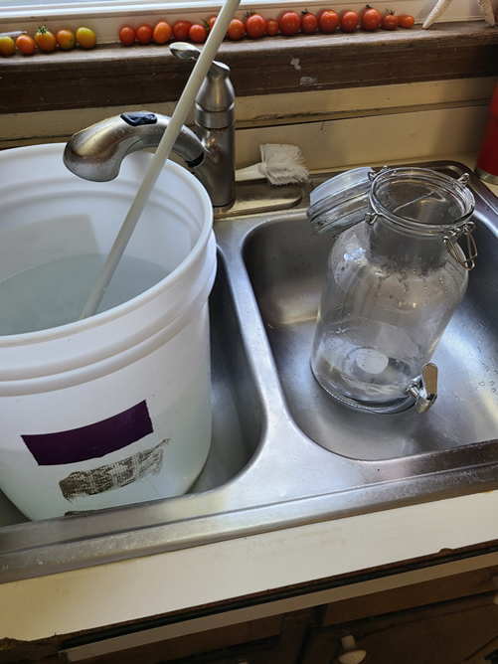
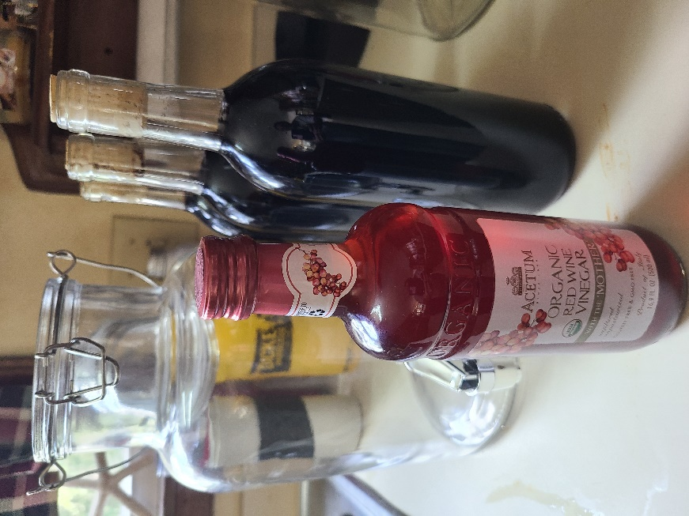
Figure 2
Figure 1
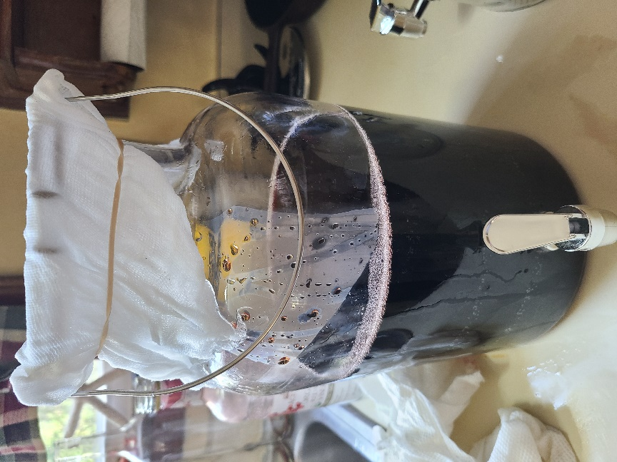
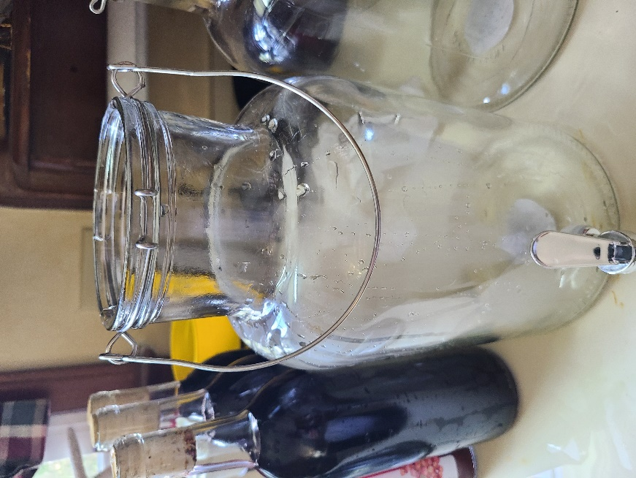
Figure 4
Figure 3

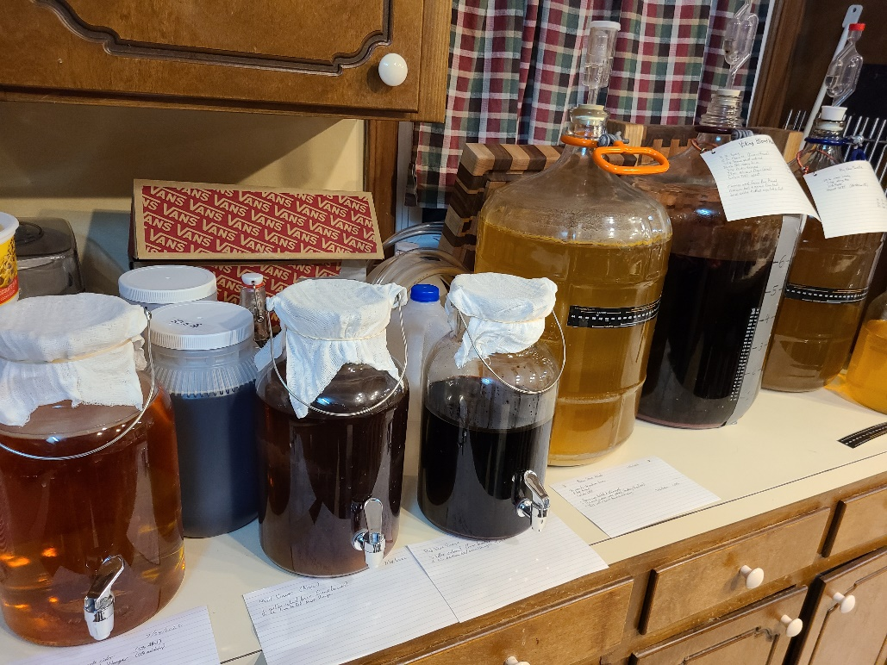
Figure 5

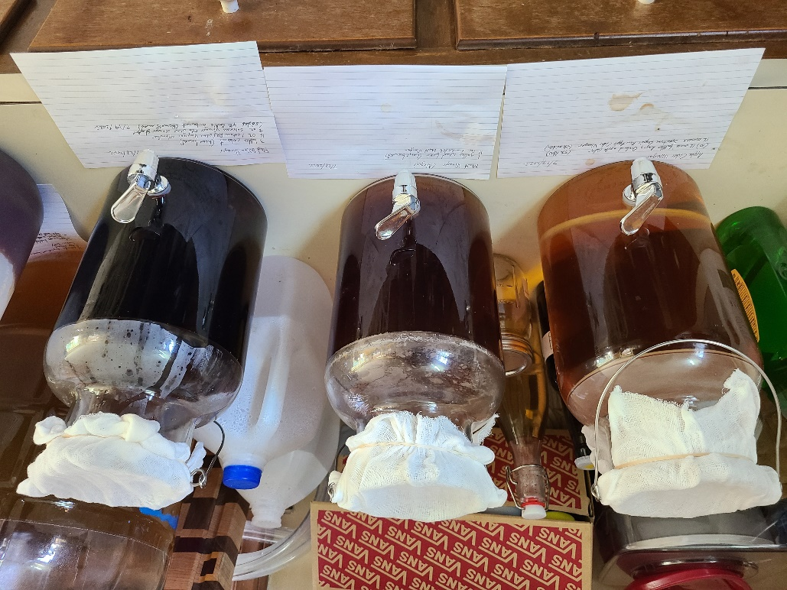
Figure 6

